We can observe from the chart above that we need to decrease dead volume to increase the power of an engine. To plot the chart, we simulate a number of individuals that produce almost fixed power (i.e. 800, 850, 900, 950 and 1000) with very little distortion. It is also noted that for each simulation with fixed power, the efficiency of the particular engine is almost constant.

$$U ∝\frac{LN_{P}}{{\left(dN_{p}\right)}^{\frac{3}{4}}}=r {\left(dN_{p}\right)}^{\frac{1}{4}}$$

The next chart try to describe the relationship between dead volume and efficiency when power is almost fixed (power = 810 ± 5). So, it is observed that efficiency of an engine is increased, when dead volume is increase. Analytically from the above equation, we can also conclude that to get better efficiency, we need to increase heat coefficient. And it is only possible by increasing the length and number of pipers of the heater. And the length can not further increase because it is being constrained by r and maximum length is set by practical implementation.

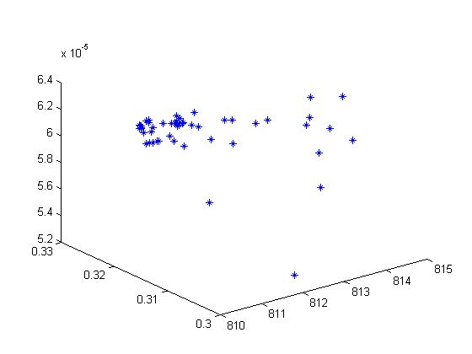

In the above, we plot a 3d chart where axes are power, efficiency and dead volume. Form the chart, it is concluded that there is no one-to-one correspondence between power and dead volume. Dead volume is a function of power and efficiency. It is carefully observed from the chart that for any combination of power and efficiency, there is a particular dead volume. Careful observation revels that there is no other dead volume for a particular combination of power and efficiency expect one.

The observation above explains why, for a given *r*, is it only possible to get certain combination of length and diameter in numerical results where efficiency is maximized. It is possible to get another combination of length and diameter by keeping *r* maximized, but for constant dead volume (with respect to maximum efficiency and fixed power), the optimizer always find the best solution for L and D (because L and D effect the dead volume).

The last question remains that why r is maximized. The answer may be in the equation above. To increase the heat co-efficient, *U*, it needs to increase *r* (maximum possible given for practical implementation) fast rather than *L and D*. After getting maximum *r*, the optimizer increase *L and D* until it reaches the maximum limit of dead volume for fixed power.

In another word, our problem is to maximize efficiency at a given power. To, increase efficiency it is required to increase dead volume. As dead volume is a function of power also, after some increase of dead volume, it is not possible increase more because that also reduces the engine power. So, dead volume is maximized until it reaches the point where it effects the reduction of given power.

There is always competition on dead volume to increase or decrease it. Maximization of efficiency try to increase because of heat coefficient and fixed power constrained the volume. That’s why we are able to get a pareto front in terms of power and efficiency. The contradiction on dead volume by power and efficiency makes it possible to get the front.